Chapter 6

Results and Discussions

6.1 Table of the results/findings or graphs
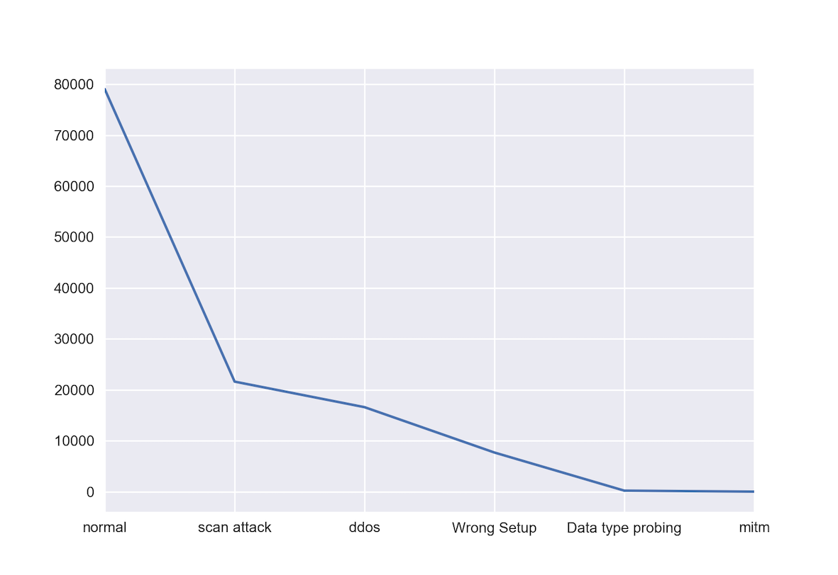
Fig 6.1 Attack distribution
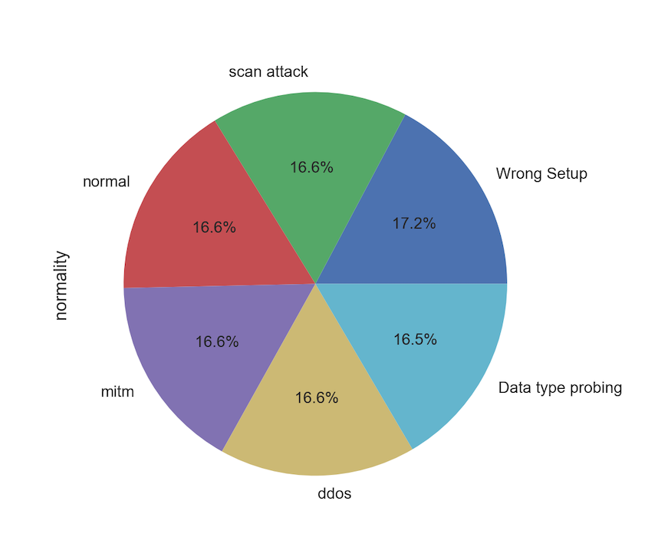
Fig 6.2 Attack distribution post oversampling
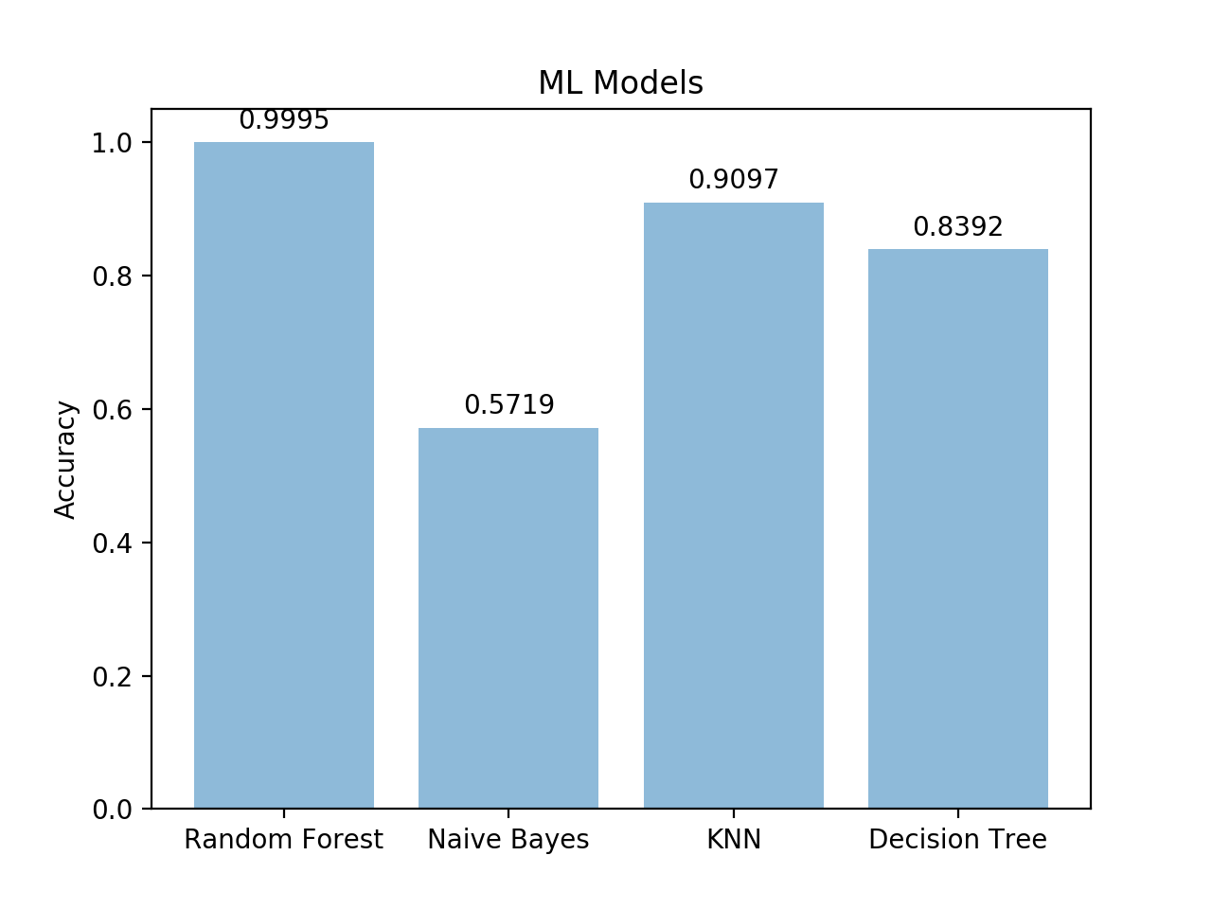
Fig 6.3 Comparison of ML models

6.2 Discussions

The dataset created had a lower number of records labeled as attack as compared to the records labeled as normal as can be seen in fig 1. This issue was resolved by the oversampling done, the results of which can be seen in the fig 2. The Random forest ML model has been proven to be more accurate than other models in comparison – Naïve Bayes, KNN and Decision Tree with an accuracy of 99.95% as compared to the 57.19%, 90.97%, 83.92% respectively as can be seen in fig 3. Although the accuracy seems very high, it has in fact been overfitted on the dataset. This means that even if it shows very high accuracy on training set, it performs poorly on new data. This has given rise to a higher rate of false alarms in the real time working of the IDS. Although this can be an issue, the advantage of this is that even if it has false alarms, it does catch all of the intrusions that occur, there by giving high true positive rates.

